**Hiring Process Analytics**

**BY**

**Rahul Patil**

**Project Description:**

1. Hiring process is the fundamental and the most important function of a company.
2. Here, the MNCs get to know about the major underlying trends about the hiring process. Trends such as- number of rejections, number of interviews, types of jobs, vacancies etc. are important for a company to analyze before hiring fresher’s or any other individual.
3. In this project we are going to analyze past interview data of candidate with company.
4. Which will help to identify suitable candidate to fill the niche.

**Approach:**

* To successfully carry out this project we are going to use **SIX STEP** of Data Analysis Process i.e (Ask, Prepare, Process, Analyze, Share, Act)
* Ask step include asking right set of question which justify goal and give motivation to carry out analysis
* We have following set of question (reasons) to justify goal of this project.
  + How many males and females are Hired ?
  + What is the average salary offered in this company ?
  + Draw the class intervals for salary in the company ?
  + Draw Pie Chart / Bar Graph ( or any other graph ) to show proportion of people working different department ?
  + Represent different post tiers using chart/graph?
* Prepare: We have data in excel format which need to first clean, transform and load into correct format to make it suitable for analysis purpose.
* This step includes selecting right data, tools, data source to make project successful
* Process: Data we have in excel format we need to clean data such as removing null values, identifying data type, removing outliers which affect the analysis.
* Analyze: We are using excel itself which come with inbuilt statistical formulae and visualization tool to analyze data to draw insight.
* Share: we are showing data obtain from analysis in the form of row and column as well as chart wherever required for better and easy understanding.
* Act: Step include taking decision based on insight opt from this project.

**Tech-Stack Used:**

* We are going to use excel which come with inbuilt statistical formulae and visualization tool to analyze data to draw insight.
* In this project we are not going to perform complex analysis so excel make it suitable tool to analyze this data for simple ad-hoc analysis.

**Insights:**

Let’s first understand data

There are 7 columns

**application_id:** application id of candidate applying for open position.

* + No null values

**Interview Taken on:** date on which interview has been taken.

* + No null values

**Status:** status of candidate after interview (Hired or Rejected)

* + No null values

**Event_name:** Gender columns Male or female

* + There are four value “- ”, “Don’t want to say”, “Male”, “Female”

**Department:** depart for which position open and interview taken.

* + There are 9 departments.
  + No null values

**Post Name:**id of post for which interview taken.

* + There are 15 post and 1 is “-”.

**Offered Salary:** salary offer to the candidate.

* + 1 null value

**Total record before cleaning = 7169**

We need to clean data by removing ‘-‘,“Don’t want to say” and null values.

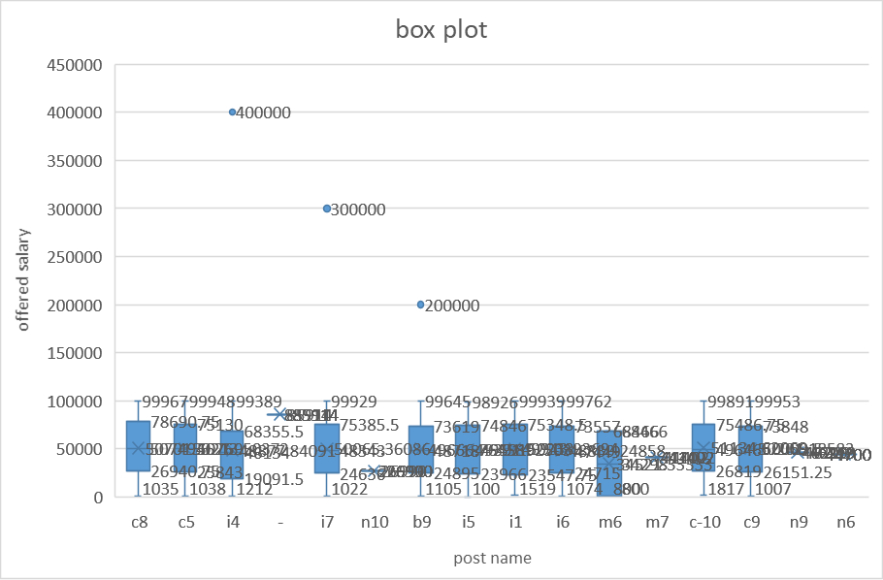

Plotting whisker plot post wise we will see there is outliers in post **b9,i7,i4**

There may be possibility that this are exceptional case where employer ready to pay this high package to deserve candidate but for our analysis this should be exclude otherwise it will make a data highly skew.

**Total record after cleaning = 6756**

**Insights:**

1.How many males and females are Hired?

**Male percentage is higher than female by 21%**

**61% male while female percentage is 40%**

2.What is the average salary offered in this company?

**Following department have highest salary package**

|  |  |
| --- | --- |
| **Department** | **Average of Offered Salary** |
| General Management | 55668.90 |
| Purchase Department | 52667.48 |
| Service Department | 50810.64 |
| Finance Department | 50400.33 |

**Post wise highest average salary offer for following post**

|  |  |
| --- | --- |
| **Post Name** | **Average of Offered Salary** |
| c8 | 51619.19 |
| c-10 | 50948.79 |
| c5 | 50110.75 |
| c9 | 50010.28 |

**Post wise lowest average salary offer for following post**

|  |  |
| --- | --- |
| **Post Name** | **Average of Offered Salary** |
| m6 | 34521.33 |
| n10 | 26990.00 |

3.Draw the class intervals for salary in the company?

|  |  |
| --- | --- |
| **Salary** | **Count of Offered Salary** |
| 50800-60799 | 733 |
| 40800-50799 | 723 |
| 70800-80799 | 698 |
| 800-10799 | 691 |
| 20800-30799 | 684 |
| 10800-20799 | 680 |
| 30800-40799 | 667 |
| 60800-70799 | 659 |
| 80800-90799 | 645 |
| 90800-100799 | 575 |

4.Draw Pie Chart / Bar Graph (or any other graph) to show proportion of people working different department?

|  |  |  |  |  |  |
| --- | --- | --- | --- | --- | --- |
| Department | Female | Male | Total | Female% | male% |
| Finance Department | 258 | 14 | 272 | 94.85% | 5.15% |
| General Management | 151 | 10 | 161 | 93.79% | 6.21% |
| Human Resource Department | 36 | 57 | 93 | 38.71% | 61.29% |
| Marketing Department | 102 | 210 | 312 | 32.69% | 67.31% |
| Operations Department | 960 | 1639 | 2599 | 36.94% | 63.06% |
| Production Department | 141 | 220 | 361 | 39.06% | 60.94% |
| Purchase Department | 108 | 200 | 308 | 35.06% | 64.94% |
| Sales Department | 248 | 465 | 713 | 34.78% | 65.22% |
| Service Department | 669 | 1267 | 1936 | 34.56% | 65.44% |
| **Grand Total** | **2673** | **4082** | **6755** | **39.57%** | **60.43%** |

**Finance & management department have high female employees almost 95% are female.**

**It make sense No one can beat female in finance, saving cost to managing all expenses female can handle better way than male.**

**This organization use people psychology to run the finance & management that’s why there are 95% female employees working only in this 2 department.**

**Rest of department have 60 -65% of male employees while female employee are 30-40 %.**

5.Represent different post tiers using chart/graph?

**Operation & service department have highest numbers of employees.**

**Out of total employees almost 39% working in Operation while 29% working in Service department.**

**Result:**

* In this project we understand how to use SIX step process of Data analysis.
* In this project we learn to use excel pivot to perform ad-hoc analysis and different chart and graph to represent data.
* **Key project insight are:**
  + 61% male while 39% female hired in this organization.
  + General Management, Purchase Department, Service Department, Finance Department this department offer higher salary than other department.
  + c8, c-10, c5, c9 this post has higher salary than other post.
  + Finance & management department have high female employees almost 95% are female.
  + Rest of department have 60 -65% of male employees while female employee are 30-40 %.
  + Operation & service department have highest numbers of employees.
  + Out of total employees almost 39% working in Operation while 29% working in Service department.